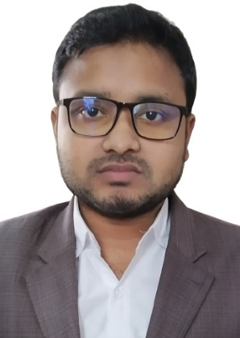**RESUME**

**OF**

**MD. ISHAQ HOSSAIN**

## ADDRESS:

Room No. 313, Akhtaruzzaman Elias Hall

Dhaka College, Dhaka-1205

Contract No: 01783629582 & 01571783141

E-mail: [ishaqhossain98@gmail.com](mailto:ishaqhossain98@gmail.com)

## CAREER OBJECTIVE:

I want to work in a place where I can learn different and interesting activities. To work in such an environment where I can improve myself in organization arena and where my creativity can be effectively utilized in an honest way so that I can use those creative in future.

## EDUCATIONAL QUALIFICATION:

|  |  |  |  |  |  |
| --- | --- | --- | --- | --- | --- |
| Exam Title | Major Subject | Board/University | Result | Pass. Year | Duration |
| Bachelor of Arts  (BA) | Bangla | Dhaka University |  |  | running |
| HSC/Alim | Humanity | Madrasah | GPA: 4.57 Out of 5 | 2015 | - |
| SSC/Dakhil | Humanity | Madrasah | GPA: 4.56 Out of 5 | 2013 | - |

## TRAINING SUMMARY:

|  |  |  |  |  |  |  |  |
| --- | --- | --- | --- | --- | --- | --- | --- |
| Training Title | Topic | Institute | Country | Location | Year | Duration |  |
| Graphics  &  Web  UI Design | Adobe Photoshop,  Adobe Illustrator | BASIS Institute of Technology &  Management  (BITM) | Bangladesh | Kawran Bazar, Dhaka | 2018 | 3 Months |

## SKILL & ATTRIBUTE:

* Self motivated individual with strong drive to achieve targets deadlines.
* Well disciplined and organized, presentable, energetic and enthusiastic with communication skills.
* Innovative and always eager to analyze plan, ability to work independently or in a group.
* Easily adjustable with any environments or places.

## MY STRENGTH:

* + - Skilled in goal setting, planning, and motivating people in achieving their targeted goal.
    - Good in generating different new ideas.
    - Enjoy working under pressure and eager to learn.
    - Good and cooperative in group work.

## LANGUAGE PROFICIENCY:

* Good in English for speaking and writing.
* Also in Bangla language.
* Have some knowledge in Arabian language.

## INTEREST AND HOBBIES:

* Expanding communication network with old and new people, reading, traveling, Swimming,by cycling, watching movie.
* Writing stories and painting.

## PERSONAL INFORMATION:

Name : Md. Ishaq Hossain

Father’s Name : Md. Kholilur Rahman

Mother’s Name : Kohinur Sultana

Date of Birth : 12-10-1998

Gender : Male

Religion : Islam

Nationality : Bangladeshi by birth

Marital Status : Single

Blood group : O+

Permanent Address : Mahishamura, Ekdala, SirajganjSadar, Sirajganj.

Current Location : Bakshibazar, Chawkbazar, Dhaka-1211

## DECLARATION

I hereby, declare that the above information in the resume is true & correct to the best of my knowledge & behalf.

# Signature& Date

